44 38

Name: __________________
Date: __________________

1. The original weight of a panda was $80 kg$. Its weight first decreased by $10\%$ due to illness and then increased by $10\%$ after recovery. After recovery, what was the change in its weight as compared to the original weight?
A. no change
B. an increase of $0.8 kg$
C. a decrease of $0.8 kg$
D. a decrease of $8 kg$

C

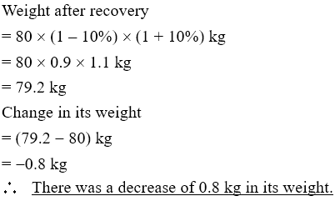

2. Last Christmas, an artist sold $40$ postcards at the price of $\$90$ each for charity. This Christmas, the price of each postcard increases by $30\%$ but the number of postcards sold decreases by $15\%$. Find the percentage change in the amount of money to charity.
A. $-15\%$
B. $+15\%$
C. $-10.5\%$
D. $+10.5\%$
D

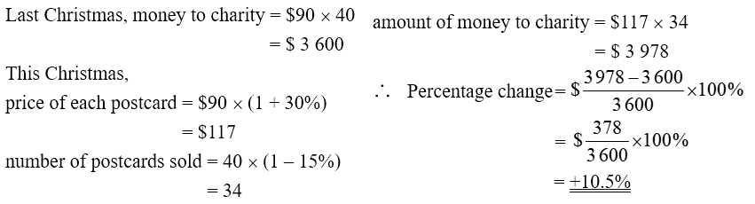

3. Bob deposits $50000$ in bank $A$ at a simple interest rate of $6\%$ p.a. and $\$40000$ in bank $B$ at a simple interest rate of $7\%$ p.a. Find the total amount he will receive after $10$ years.
A. $\$148000$
B. $\$74000$
C. $\$58000$
D. $\$12000$
A

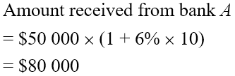
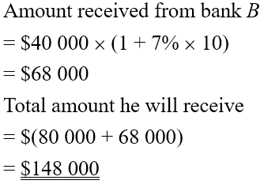

4. A sum of money is deposited in a bank at an interest rate of $12\%$ p.a. compounded yearly. If the interest received after $7$ years is $\$6000$, find the principal.
(Give the answer correct to the nearest $\$1000$.)
A. $\$3000$
B. $\$4000$
C. $\$5000$
D. $\$6000$
C
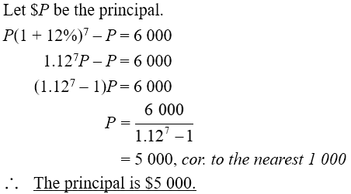

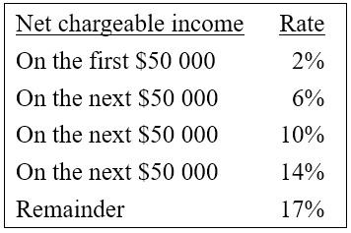
5. In this financial year, Tom has a total allowance of $\$140000$ and he has to pay a salaries tax of $\$15300$. If his net chargeable income is greater than $\$150000$ but less than $\$200000$, find his annual income.
A. $\$109000$
B. $\$195000$
C. $\$249000$
D. $\$335000$

D

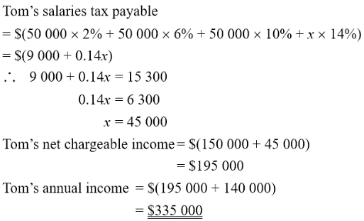

6. The value of an antique oil painting increases at a steady rate of $25\%$ every $5$ years. Its present value is $\$150000$.
(a) Find its value $20$ years ago. (4 marks)
(b) Find the increase in its value over the past $20$ years. (2 marks)

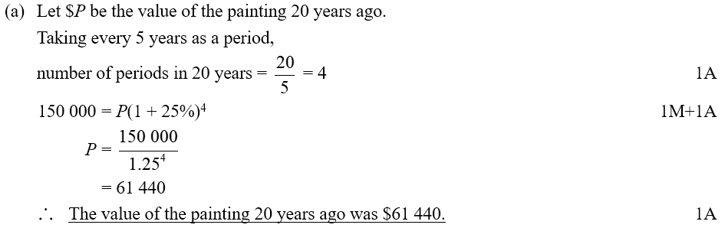
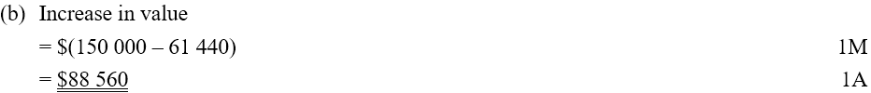

7. David borrows $\$5000$ from a bank at an interest rate of $7.8\%$ p.a. compounded monthly. Find the amount he should repay after $3$ years.
(Give the answer correct to the nearest dollar.) (4 marks)

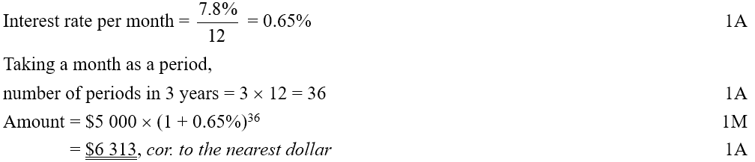

*8. Bank $X$ offers interest at $4\%$ p.a. compounded half-yearly. Bank $Y$ offers interest at $2\%$ p.a. compounded quarterly. Susan is going to deposit a sum of money in one of the banks. She claims the interest received in bank $X$ will be more than that in bank $Y$ after $10$ years. Do you agree? Explain your answer. (10 marks)

